**RoadIt application**

When you start the application, you will arrive at the home page (see picture 1). There you can click at the “Login in” button.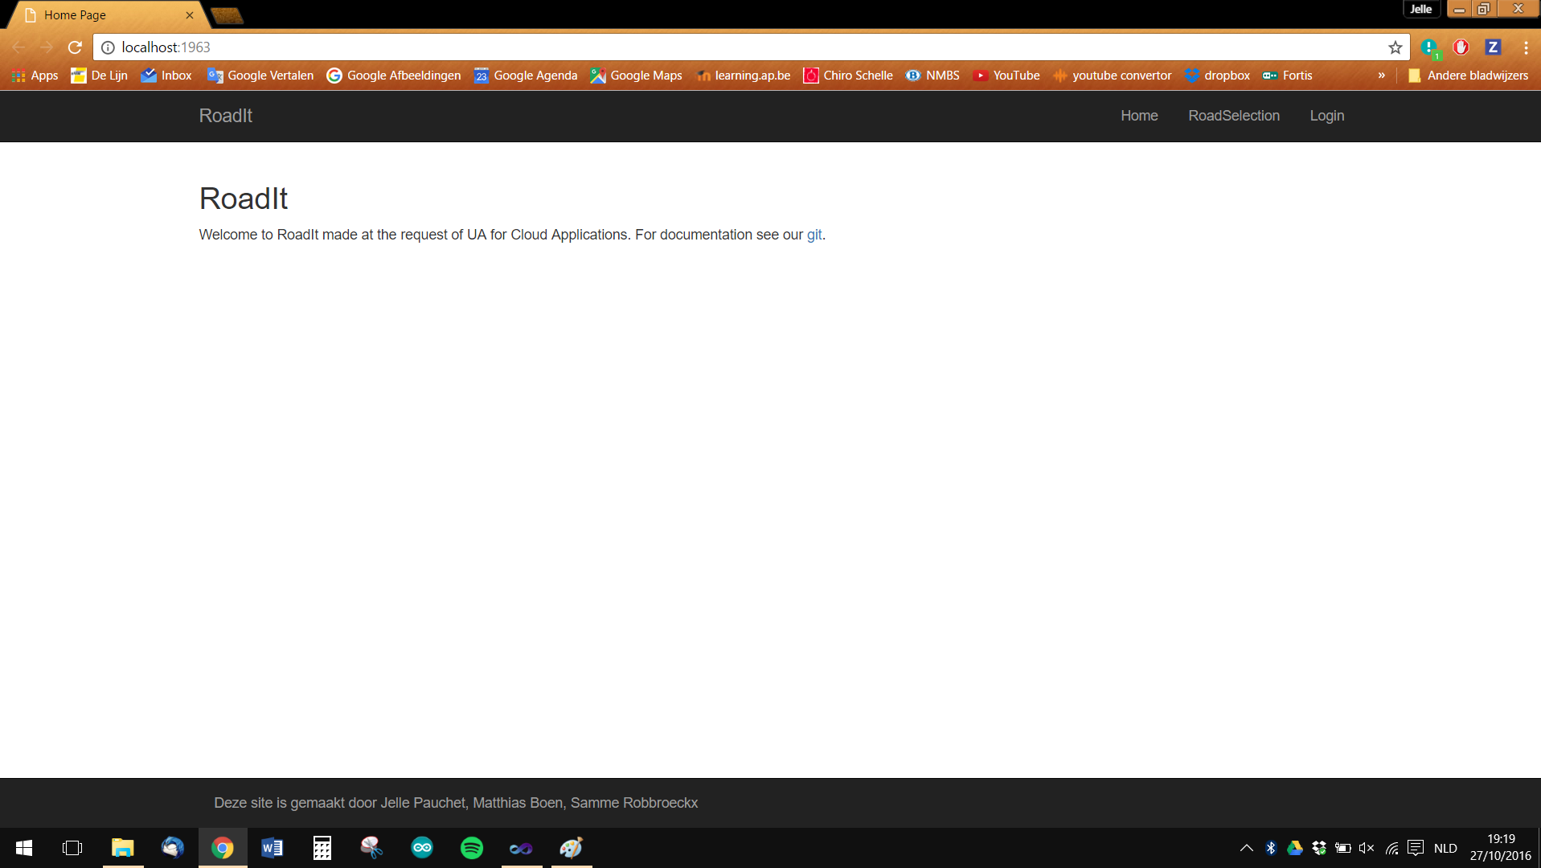

Picture 1

There you can put your email and your password (see picture 2).

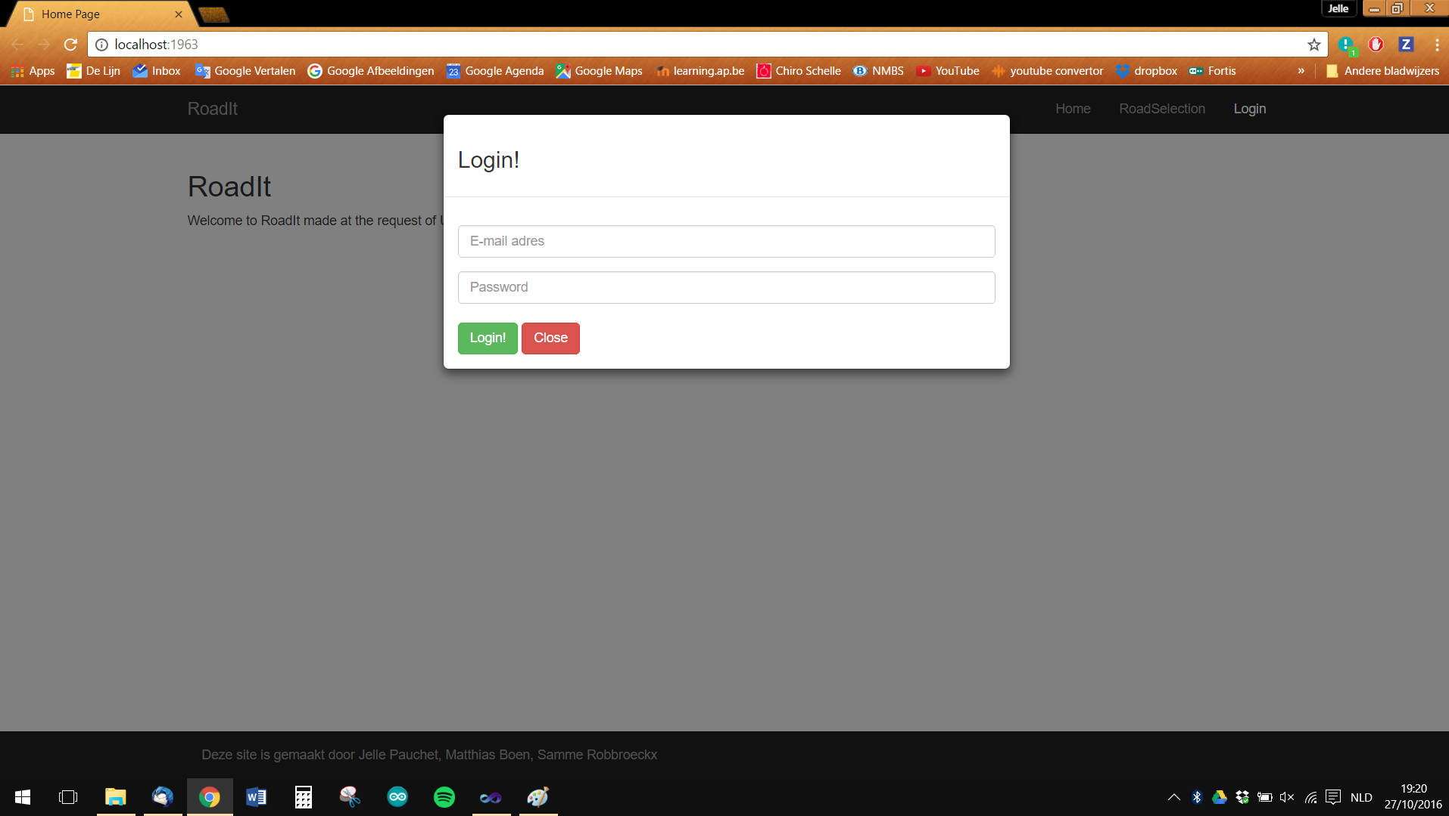

Picture 2

After you click on the “Login” button, you come on the road selection page (see picture 3). There you can choose witch data you want to see depending on the road section you choose.  
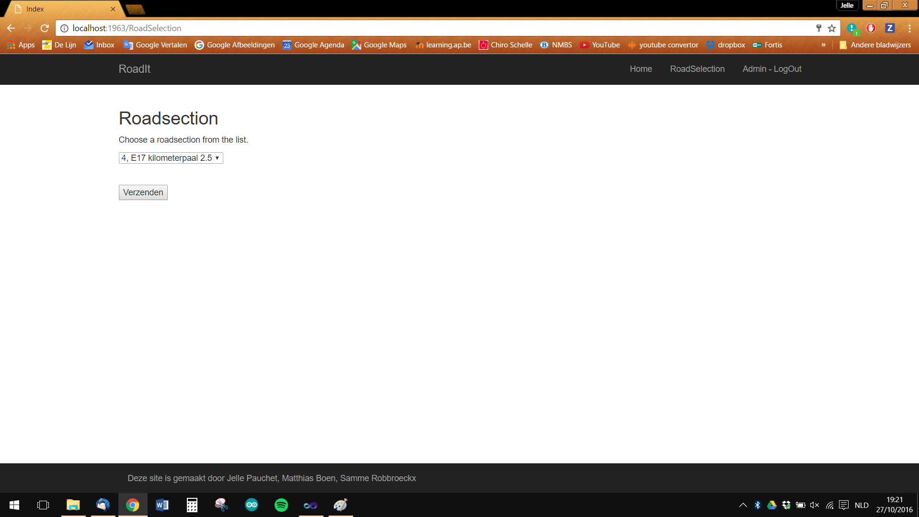

Picture 3

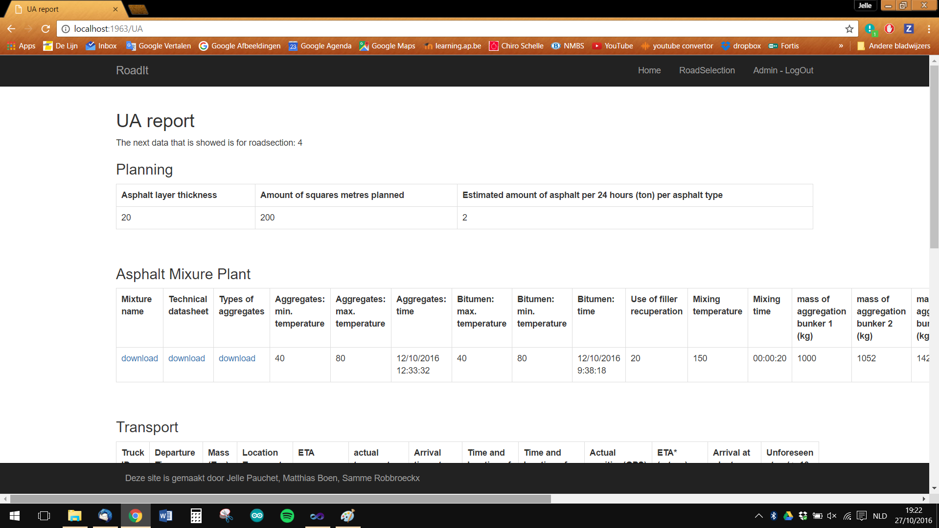After you have chosen a road section, you are automatically redirected to the report page with the information you may see (see pictures 4, 5 and 6). This is based up on your login information.

Picture 4

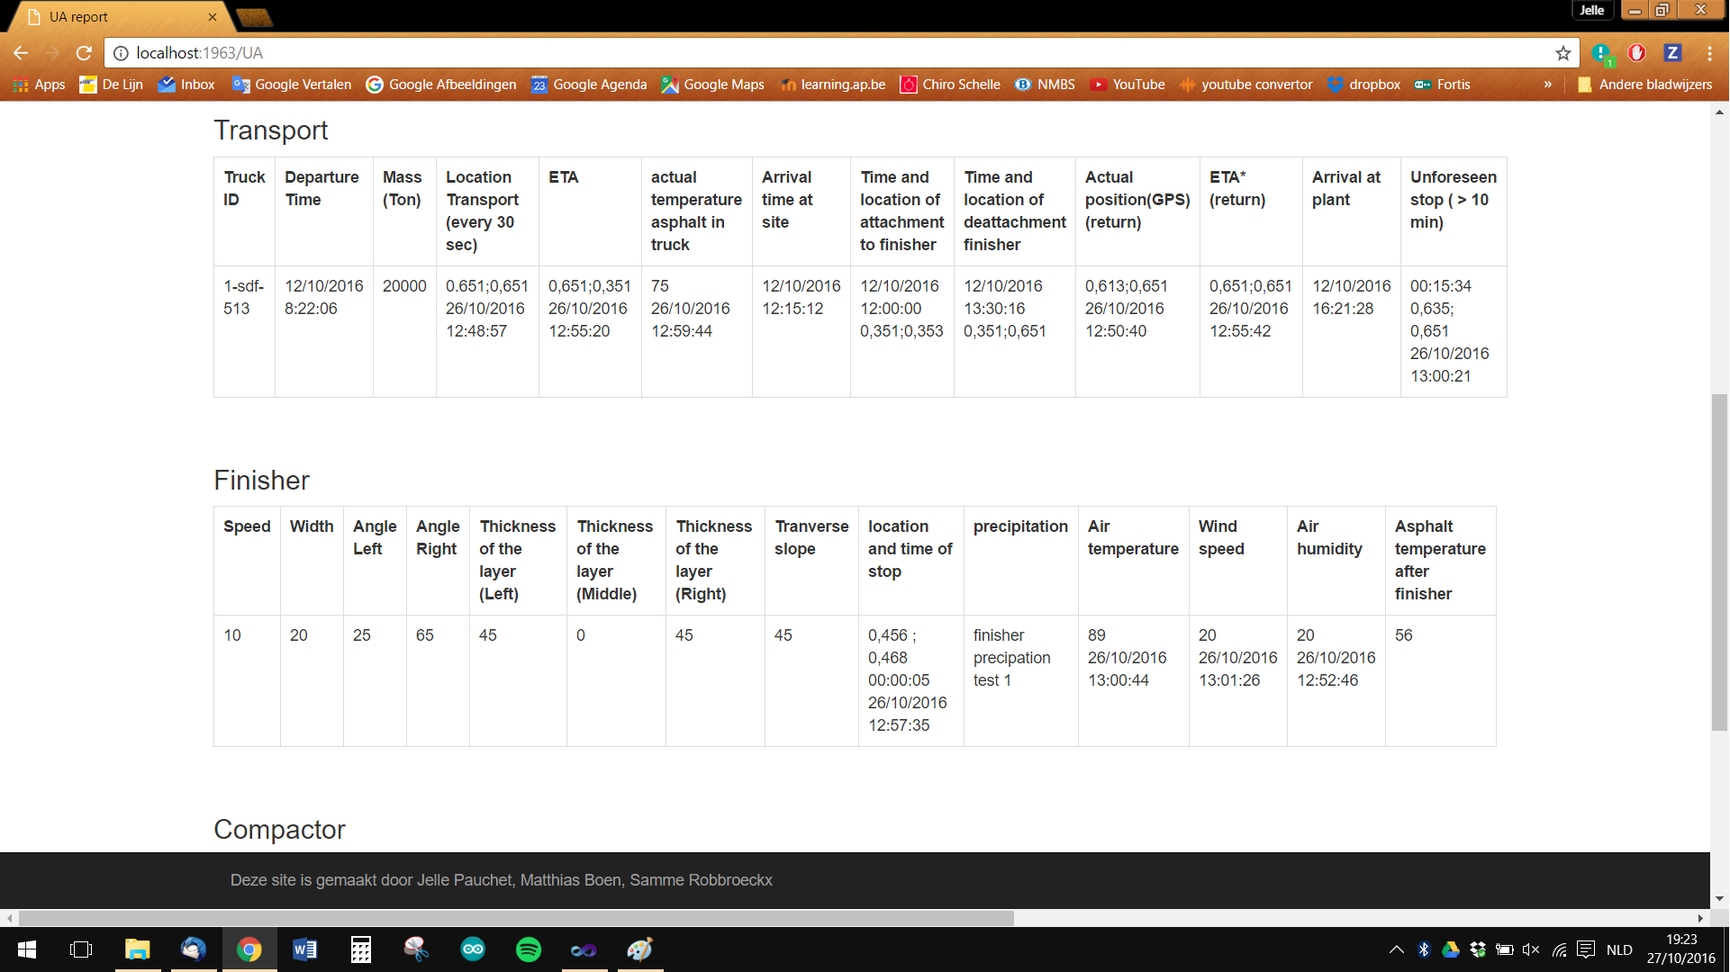

Picture 5

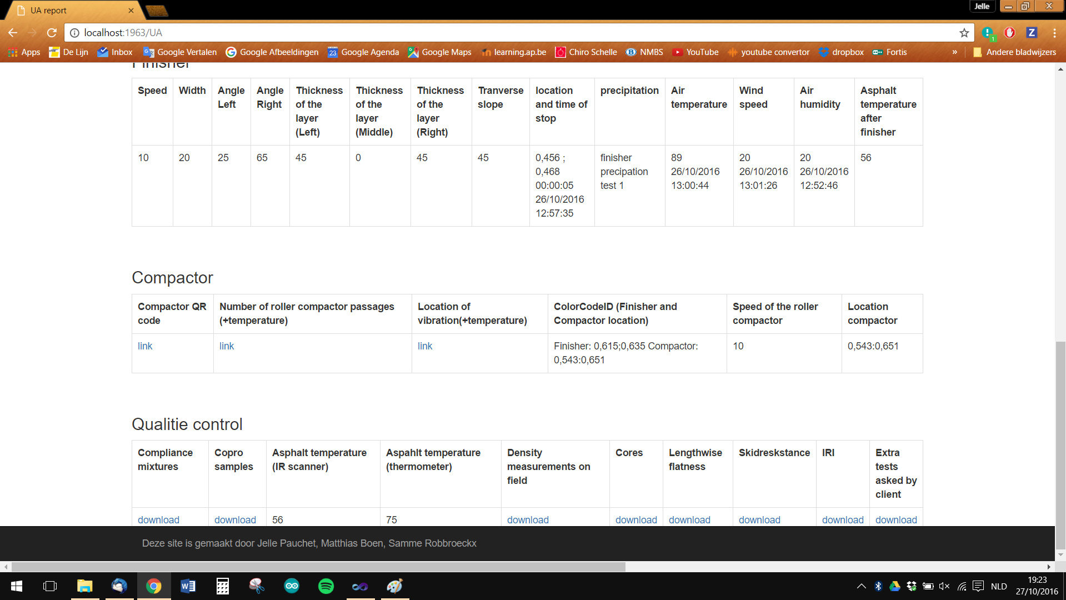

Picture 6

When you want to go to a page where you have no authorities to, you will have an error message on the screen or you will be redirected to the login screen where you have to enter another login with other authorities.

**Mapping tree**

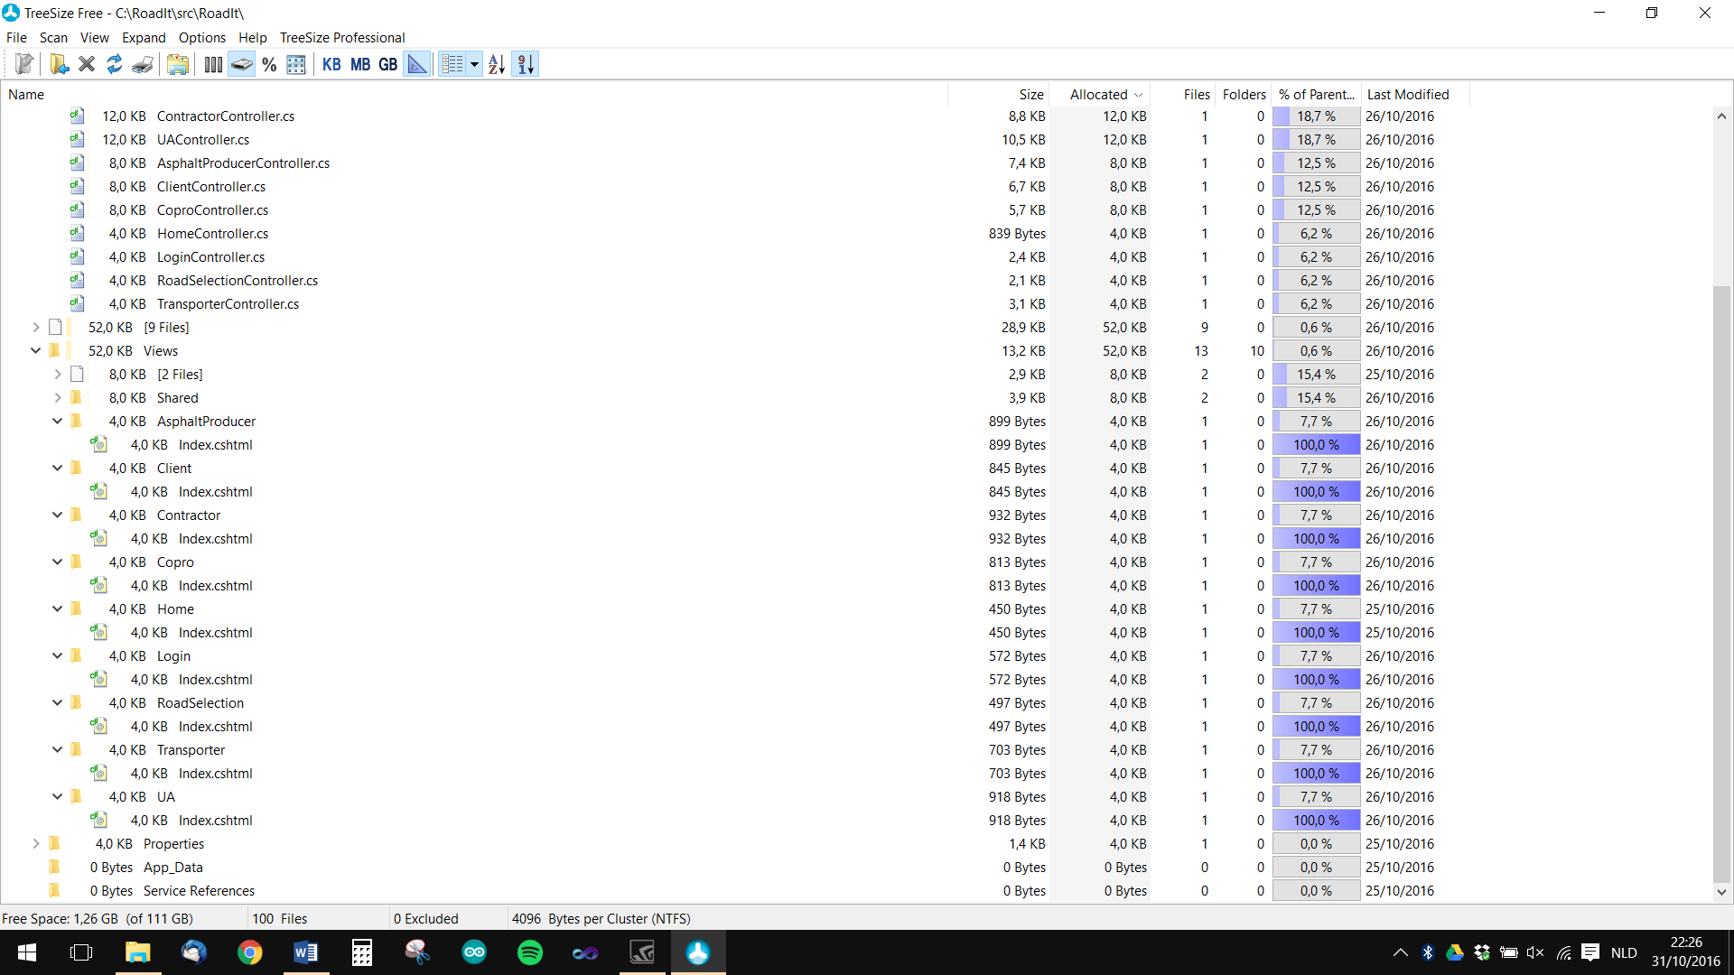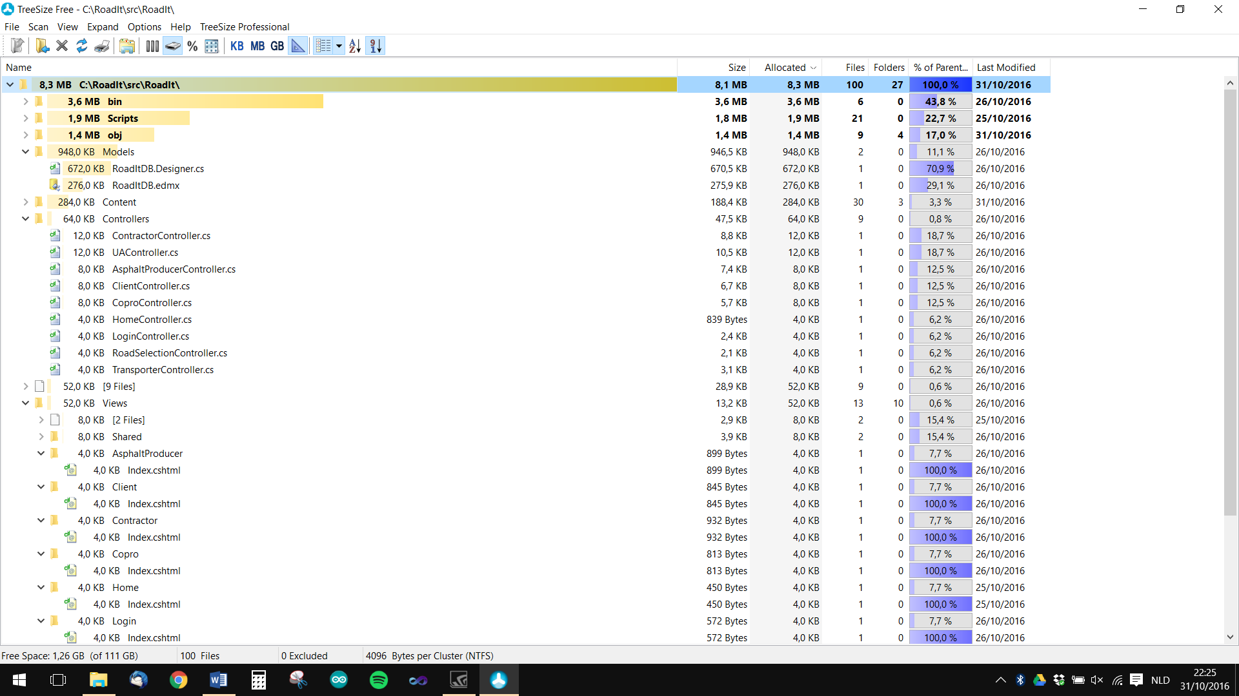

We use an entity framework to connect our application with the database. The connection happened inside the model.   
Every time we want to get something different out the database, we make a new controller. This controller is connected to the model. In every controller will be the data processed and prepared to pass to the view.   
Each controller has its own view. In this view will be the data from the controller be presented.  
When there is a redirection to a page, there will be linked to the controller, thereby will the view automatically be presented.